**PROJECT DEPLOYMENT**

**Github:** All the project documents and source code of the project has been uploaded in the following github link:

<https://github.com/sumanth2109/AppRecommender>

**Project Video:** A video telling about our application and how to use is uploaded into the UMKCLee channel and the link of the video is:

<http://www.youtube.com/watch?v=qkKMFE3H3L8>

**User manual:**

**Introduction:**

The recent surveys tell us that the google play store surpassed 1 million mark, from their total of 5, 00,000 last year. And also the number of application downloads in the Google Play store this year has reached 50 billion up from total of 20 billion last year. Apple hits 9 lakhs apps in the play store this year. These numbers indicate the amount of redundant data being increased every year. The reason behind this increase in redundant data is the user is not able to take an intelligent decision on which app to download for his requirement. These numbers tell us how significantly number of Mobile Web applications are increasing. Around 9 billion mobile users in the world are connected to the cloud and this number is expected to steep up to 24 billion by 2020. “Application Reviewer” is the primary step to help users in selecting appropriate App’s.

**Motivation:**

In the present Mobile web application industry, selecting a required application for our mobile phone is becoming more hectic for user as numbers of applications for each purpose is increasing exponentially every day and time has arrived where in another Mobile Web application needs to be developed to give the user with an intelligent, more efficient application according to his/ her needs.

**Significance:**

The Significant features of the proposed project are when a user requests information in certain category, then the application will pop up with the sorted list of best apps along with their description such as other user’s honest reviews and the ratings given by them for that particular application.

**Decision:**

We decided to develop a Mobile web application which provides users with best suited app for their requirement and suggest those related applications along with their honest reviews to user in a sorted manner. The user will also get top rated apps in the categories of his choice via email weekly.

**Description of how to use:**

In our application we have “create account” option for the new user. It asks details like username, password, confirm password and e-mail address. If any invalid data is entered it displays the errors on the top of the screen. The username field should be unique. Once the account is created we can login using the details given.

In case the user forgets his password, then by clicking “forgot password” tab it redirects him to a window where his username has to be entered. Then password reset link will be mailed to his email.

After successful login the user is asked to “choose category” of his choice to view the list of best apps in that particular category which are displayed in the descending order based on the average rating of that app. In the same way user can view the top rated apps in other categories of his choice. But here only 1 category can be selected at a time and “home” button at the end of the page redirects the user to the home page.

The user can also manage his interests among the categories, then his interests will be saved for further reference and the top rated app in that particular categories will be mailed to him weekly. In the future he can again manage his interests.

The user even has the option to change his/her password by clicking the profile tab and then “change password”. Here he/she is required to enter his/her old password then the new one. He can also manage his interests from here. Later by selecting “sign out” tab user will successfully log out of the application.

The admin of the app will have a separate account where he/she needs his/her username and password for sign in. The admin can add a new application from here. The details about new app like its name, average rating, number of recommenders, 5 star, 4 star, 3, 2, 1 star ratings and the reviews of the application have to be entered. The admin will be able to send emails to users regarding top rated apps in the categories shown by them. He can also see all the users and their interests. Admin can also upload a datafile or load data from uploaded file from his account.

**Screenshots:**

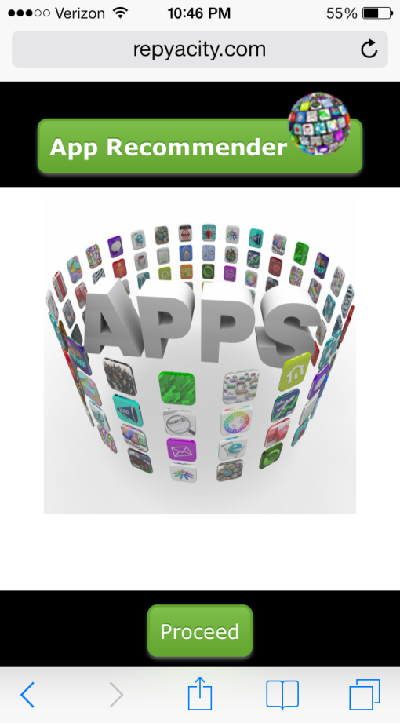

This is the starting of the mobile application. By clicking the proceed tab the user can enter into the application.

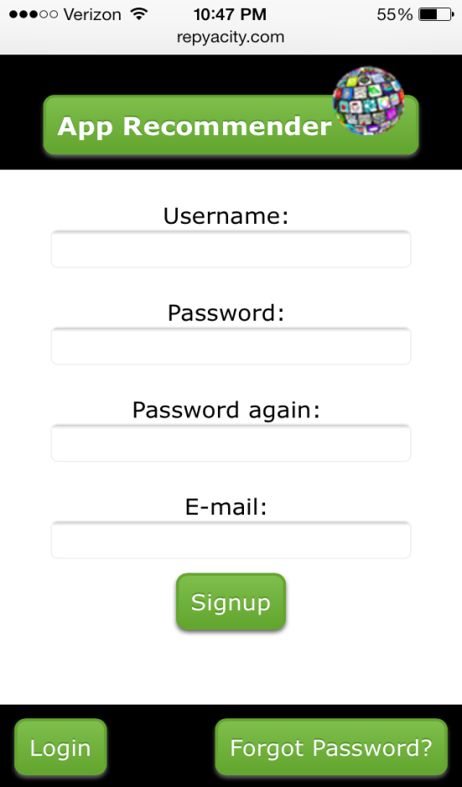

If he/she is a new user the sign up page will be displayed, where he is asked to enter details like username, password, confirm password and email address. By clicking the sign up tab his details will be saved.

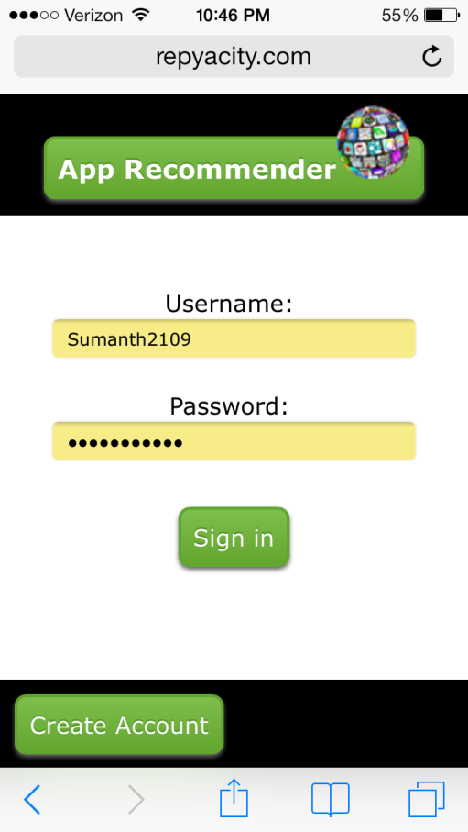

Later the user can log in with the username and password given before.

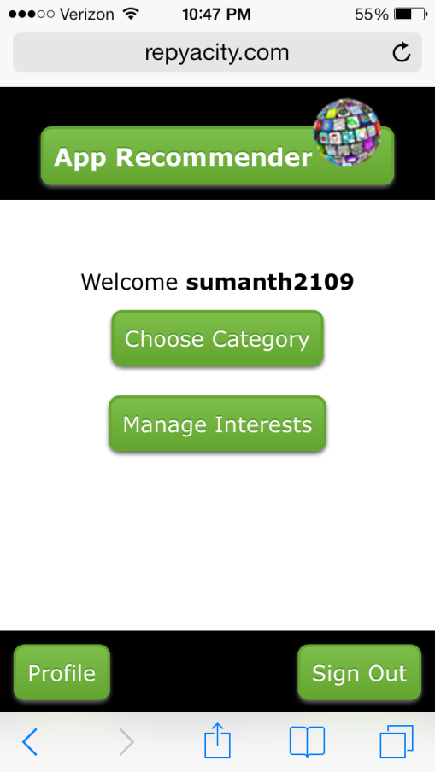

After signing in the user can select a category of his choice by clicking the choose category tab.

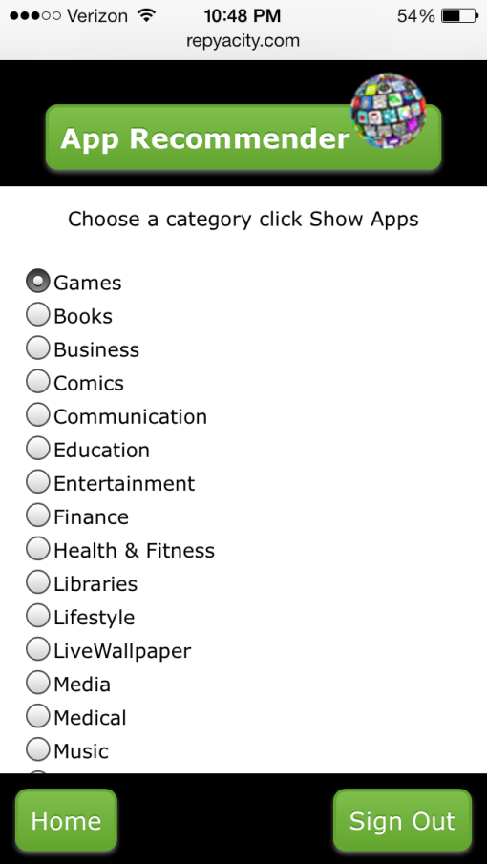

All the available categories will be displayed. The user can a select a category of his choice from the apps displayed. If example “education” is selected, then the list of apps are displayed in their order of rating.

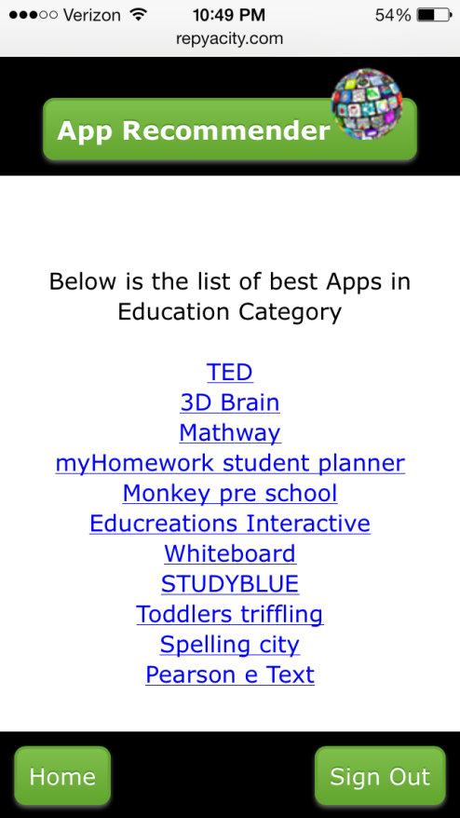

Then all the top rated apps in the education category are displayed in descending order based on average rating. The user can select an app of his choice from the list.

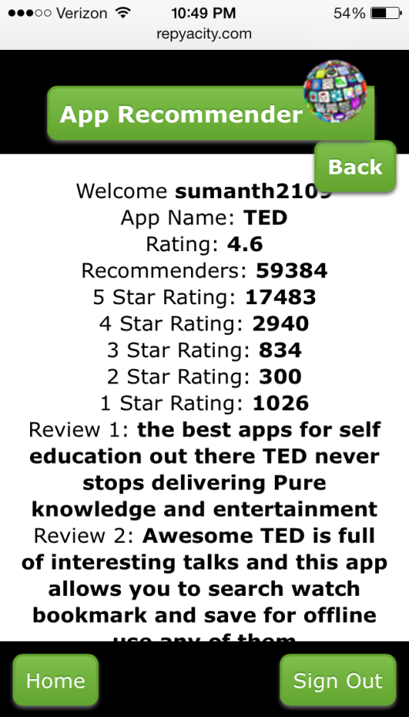

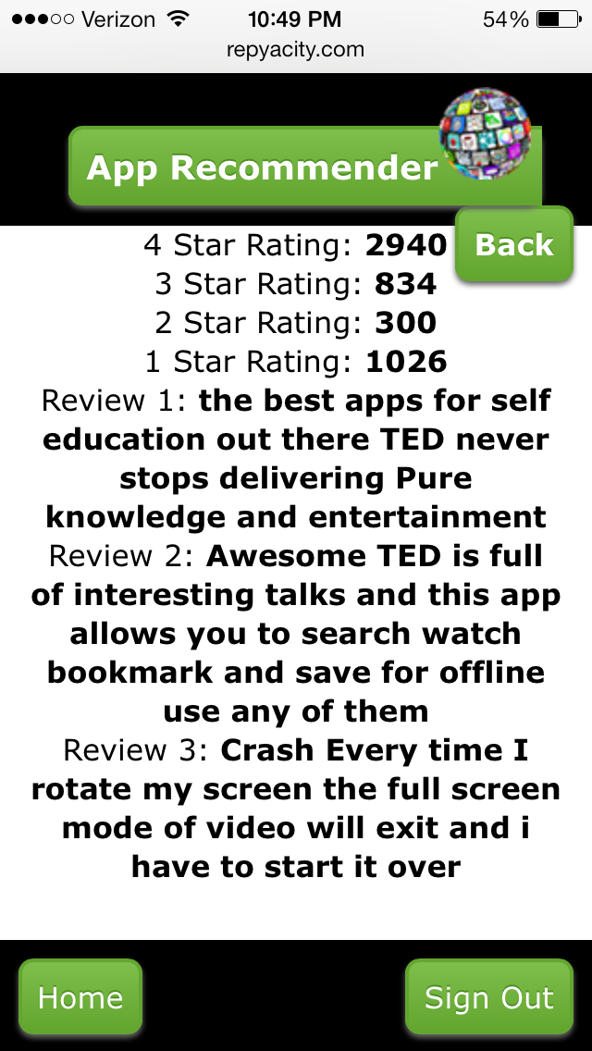

If TED app is selected from the list then all the information about the app like its rating, number of recommenders, 5 star to 1 star ratings and reviews are displayed.



Then by pressing the “home” tab user will be redirected to the home page, from where he can choose his interests by clicking the “manage interests” tab.

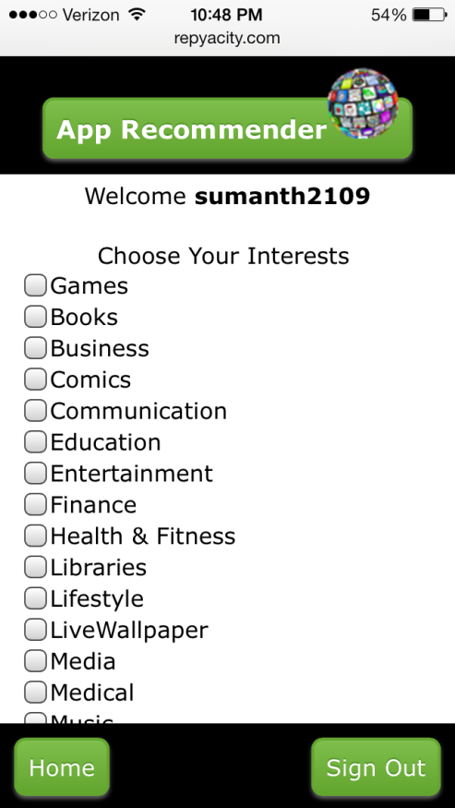

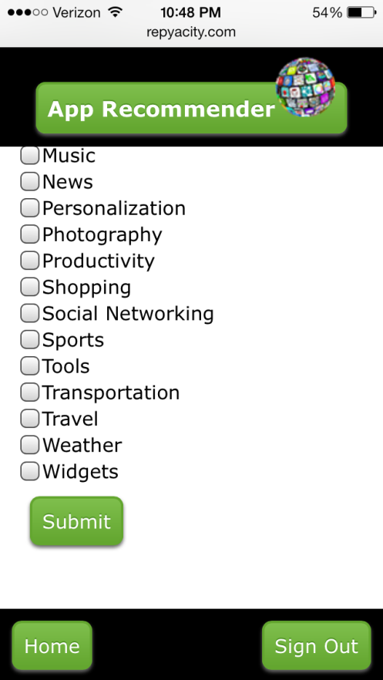

Here the user can choose multiple categories of his choice and by submitting his preferences will be saved and top rated apps will be sent to his mail weekly in the chosen categories.

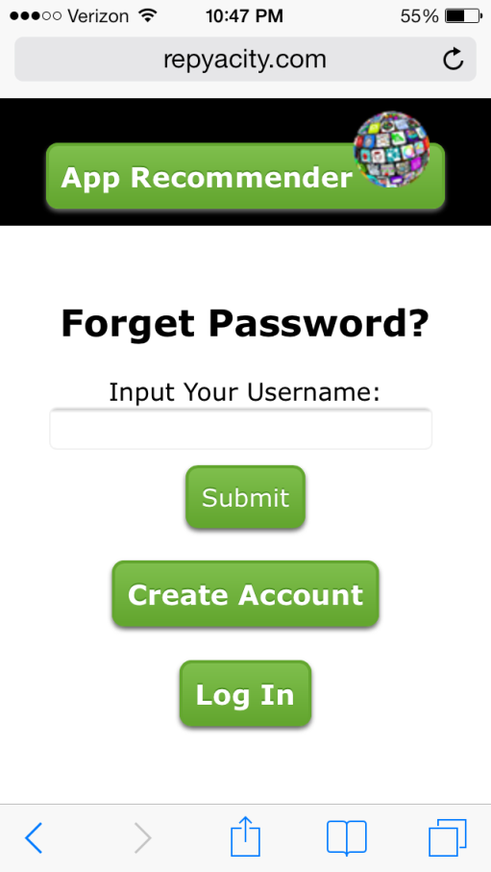

If the user forgets hos password, by clicking the forget password tab his username wll be asked. By submitting password reset link will be sent to email.

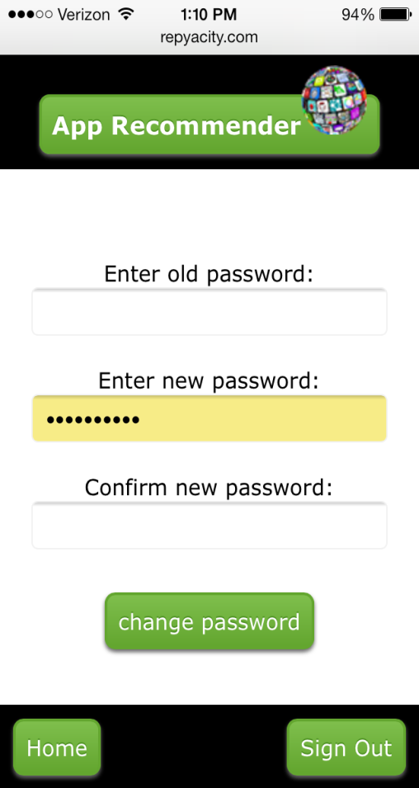

User also has the option to change the password. First he has to enter his old password then the new one.

**Error Recognition and Handling:**

Whenever a user tries to enter the application with username and password which doesn’t exist then the app doesn’t allow them to as the username is made unique. Even if we enter wrong credentials of a user, his personal profile cannot be opened.

**Bugs and Deficiencies:**

1. The bug we noticed is the email field is taking any characters during sign in.